**Estimation of Business Expenses**

**INTRODUCTION**

This report delves into the fascinating realm of business expenses and provides a visual exploration of the various expenditures incurred by different businesses. It showcases the distribution of expenses, identifies key cost drivers, and highlights areas of potential optimization or concern. The visual representations allow for intuitive analysis, facilitating a deeper understanding of expenditure patterns and their implications for business performance.

**EMPATHY MAP**

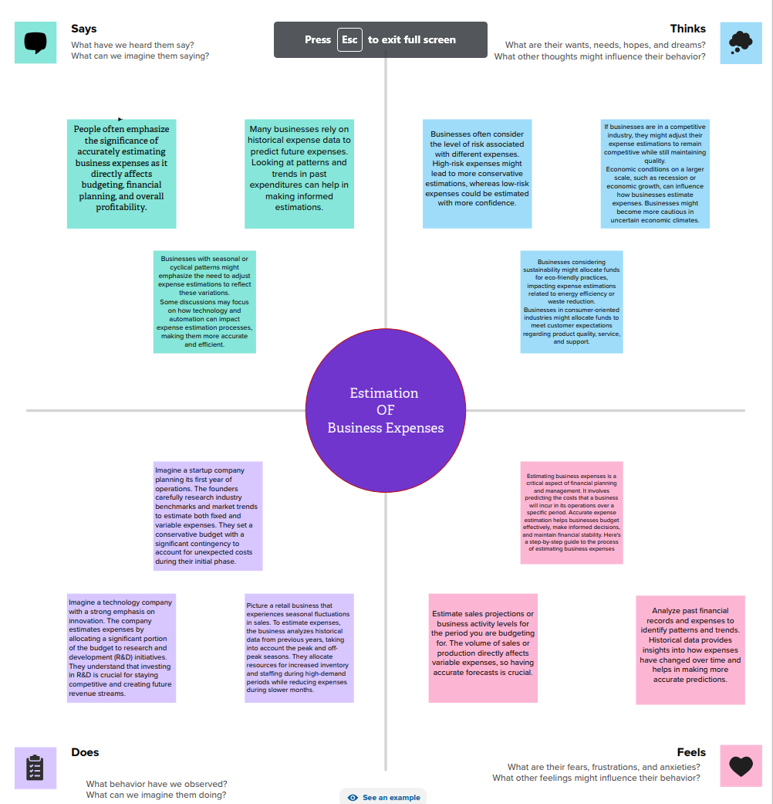

**BRAINSTORMING**

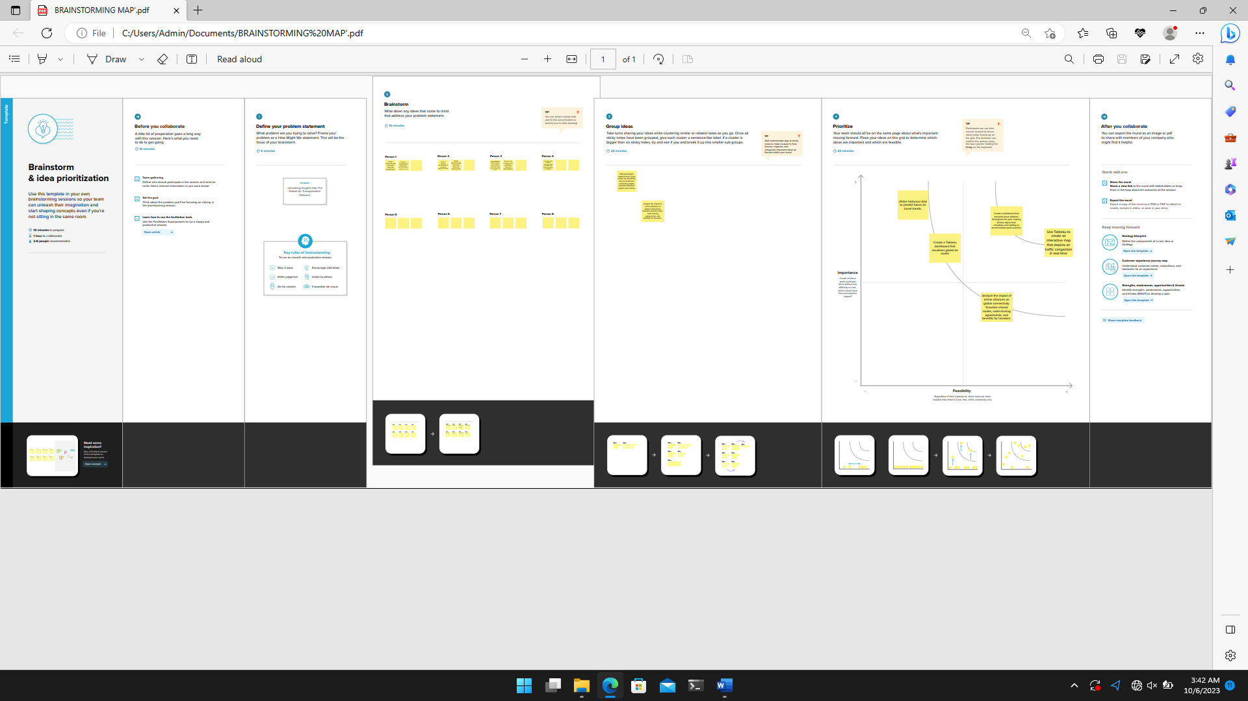

**ANNUAL PAY ROLL**

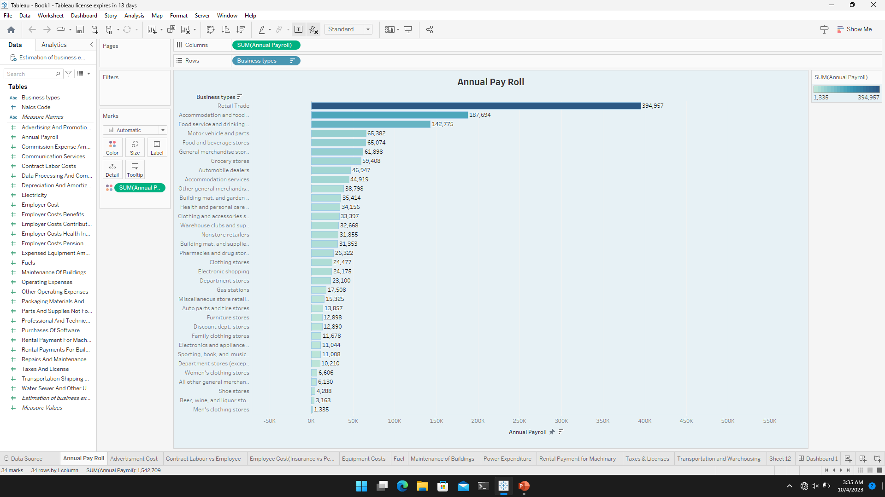

**ADVERTISMENT COST**

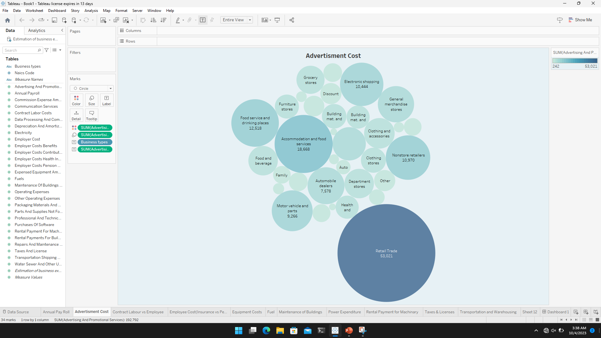

**CONTRACT LABOUR VS EMPLOYEE**

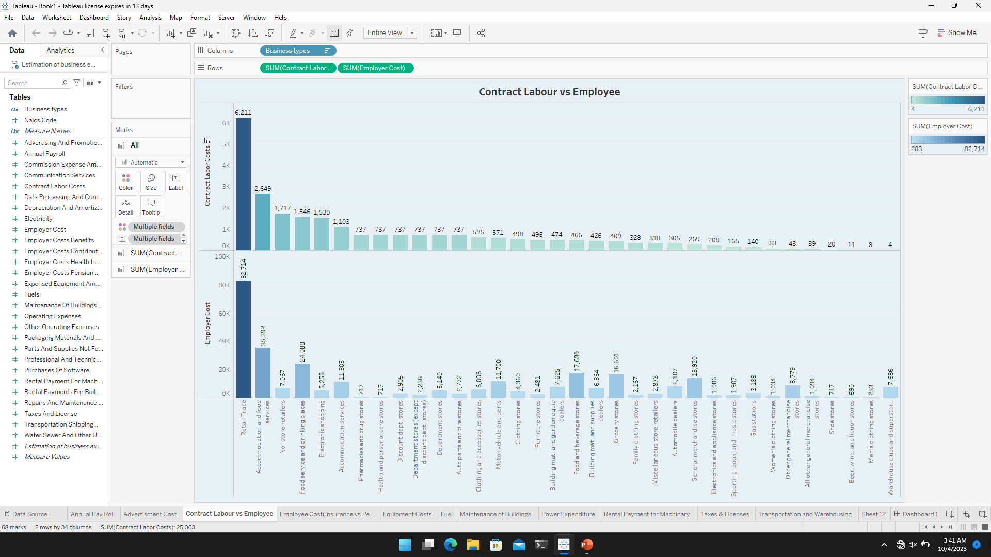

**EMPLOYEE COST(INSURANCE VS PENSION)**

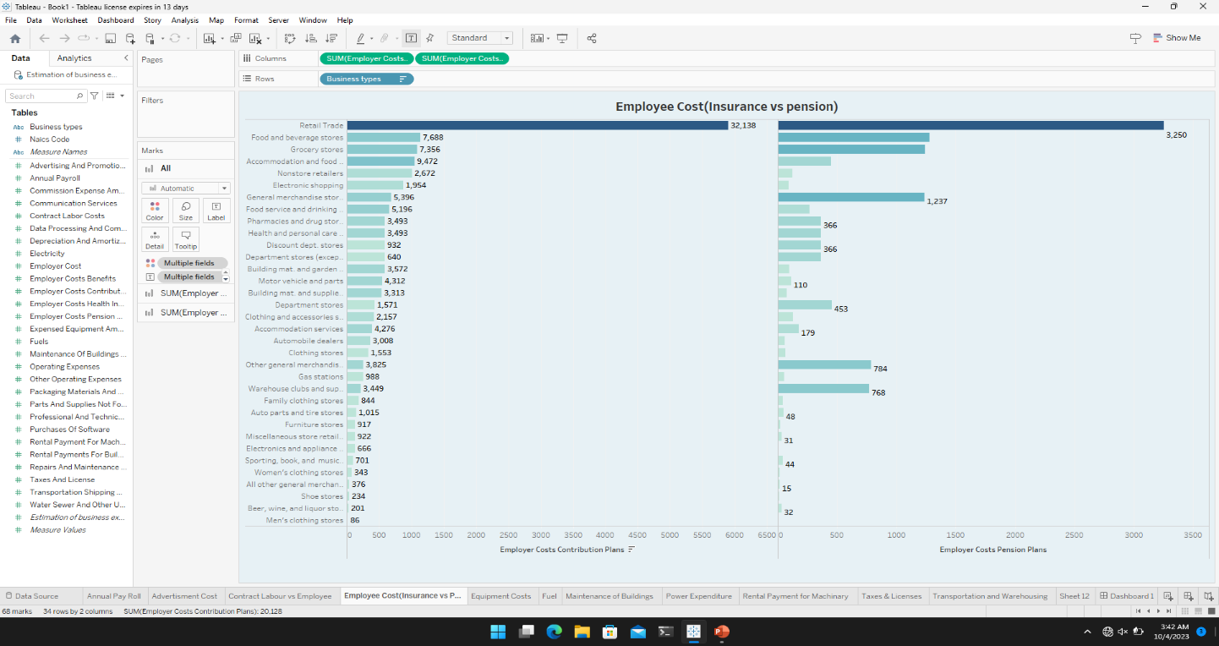

**EQUIPMENT COSTS**

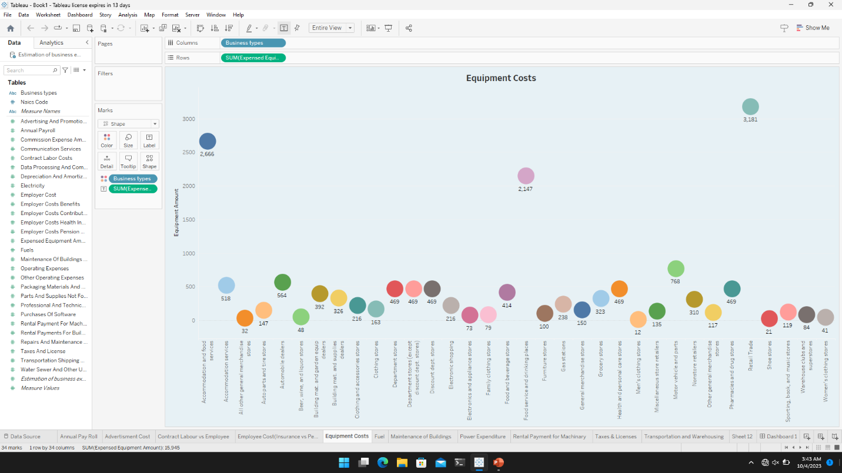

**FUEL**

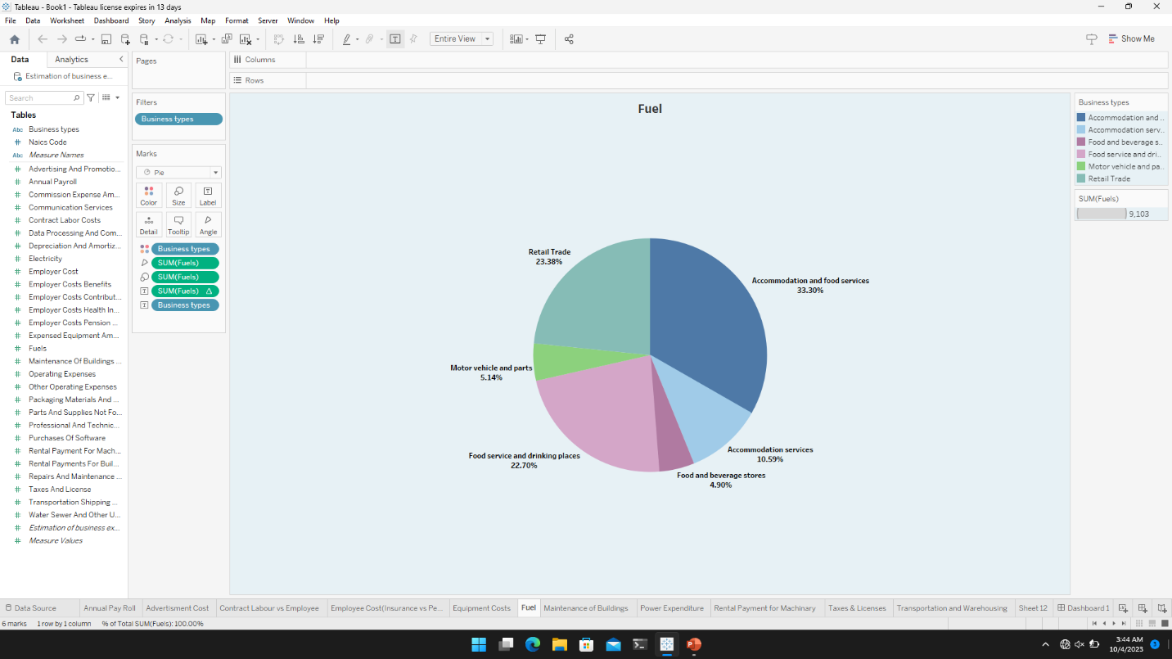

**Maintenance of Buildings**

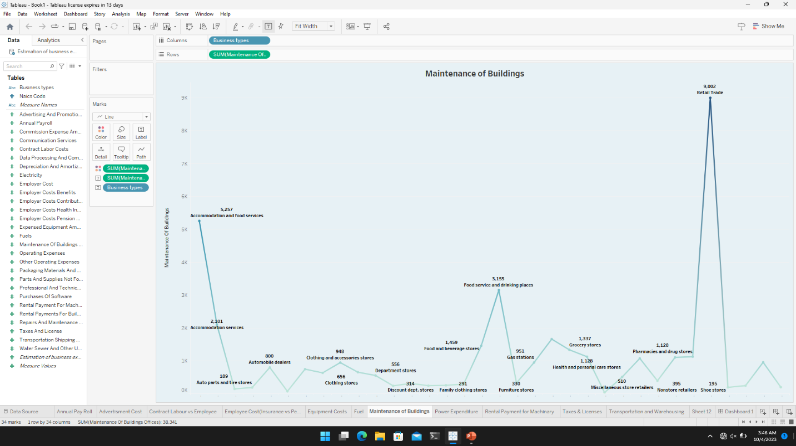

**Power Expenditure**

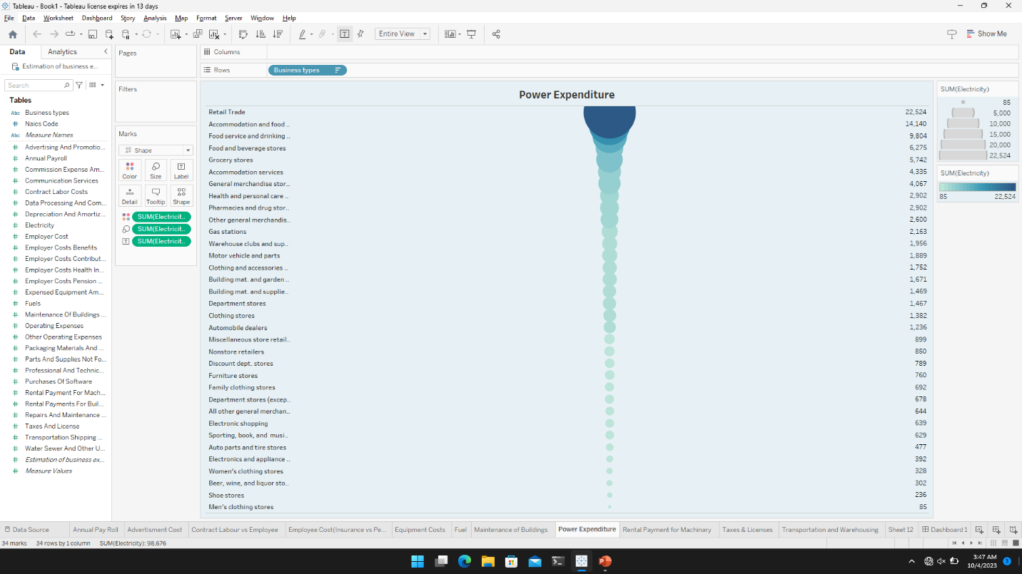

**RENTAL PAYMENT FOR MACHINARY**

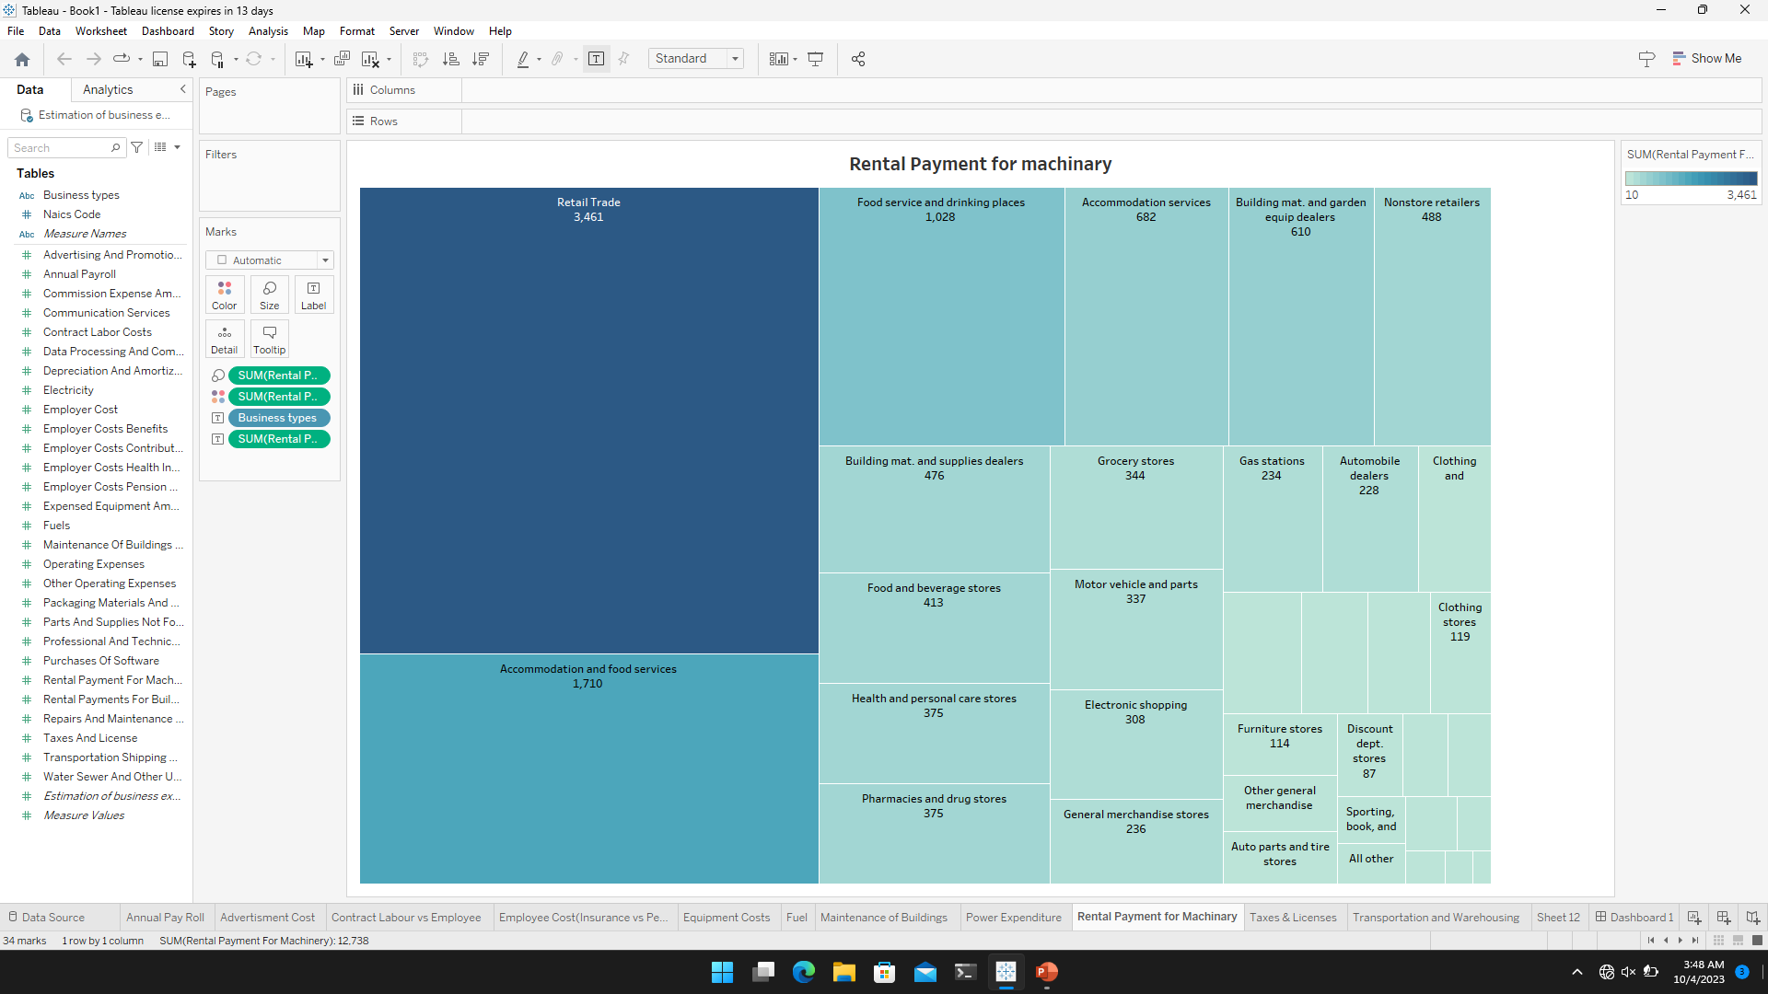

**TAXES & LICENSES**

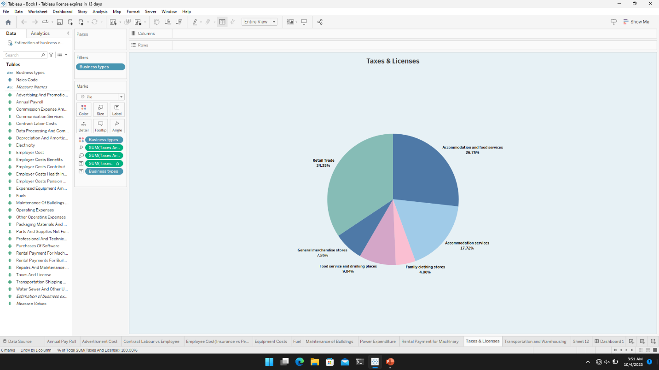

**TRANSPORTATION AND WAREHOUSING**

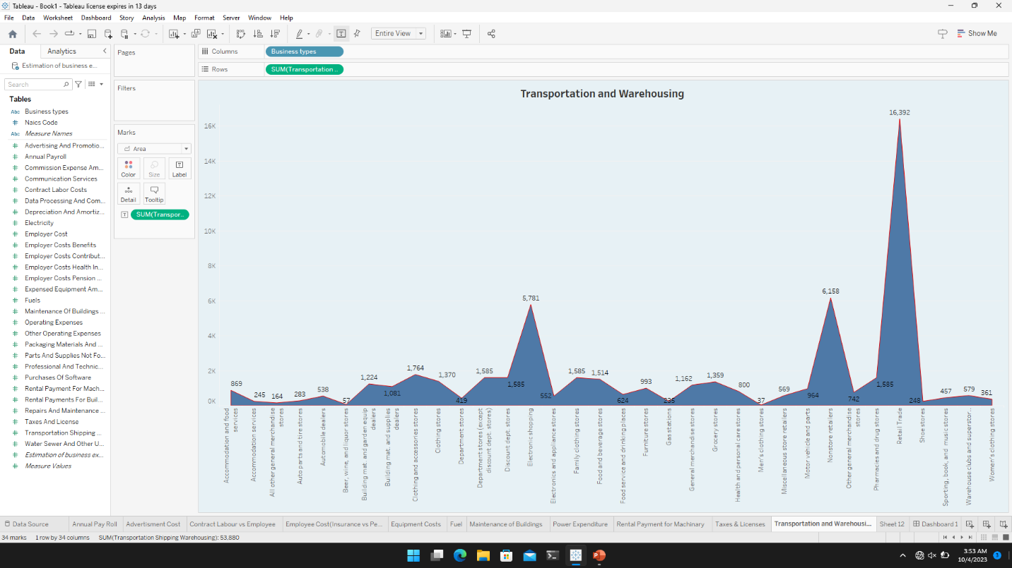

**DASHBOARD 1**

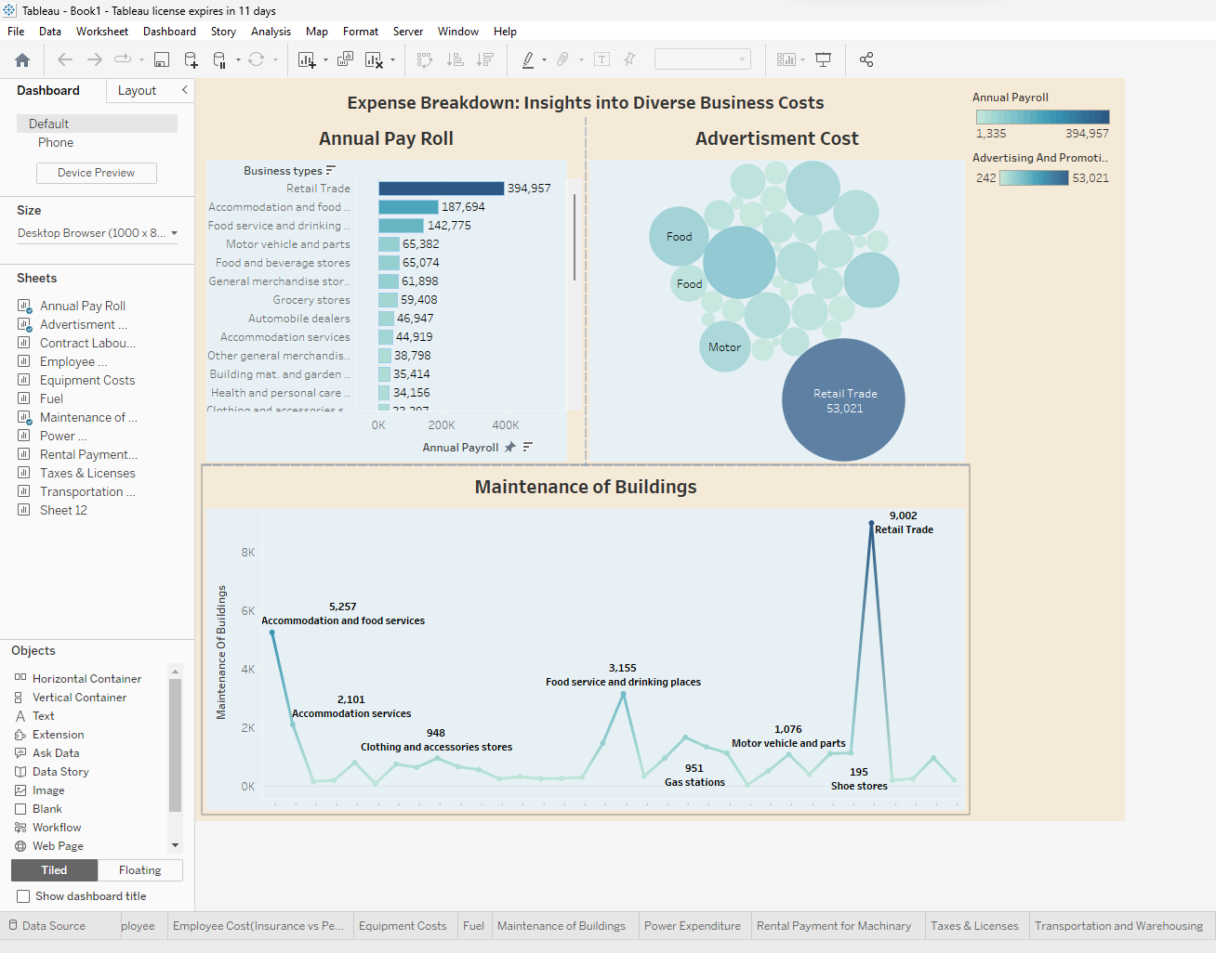

**DASHBOARD 2**

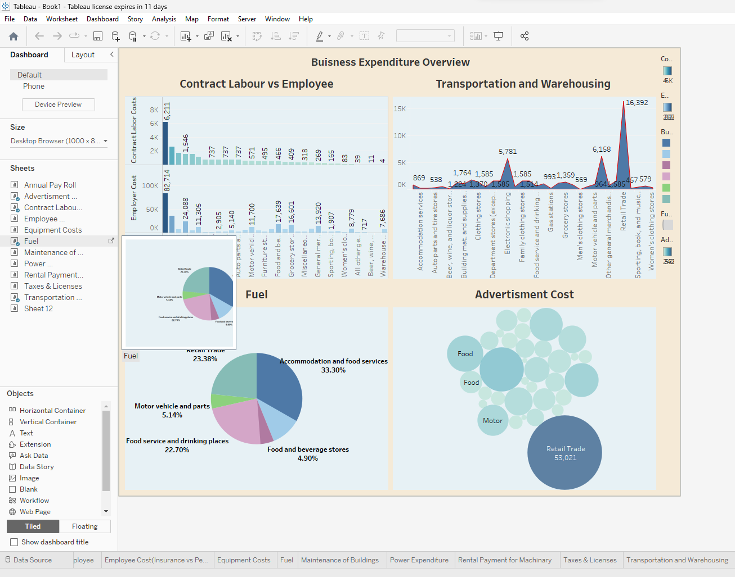

**DASHBOARD 3**

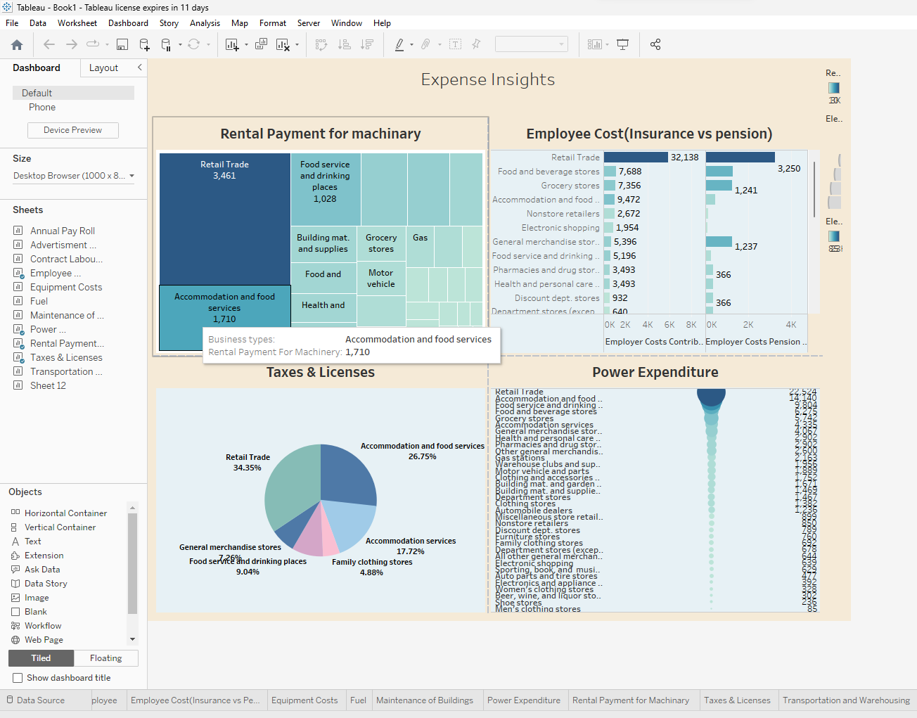

STORY 1

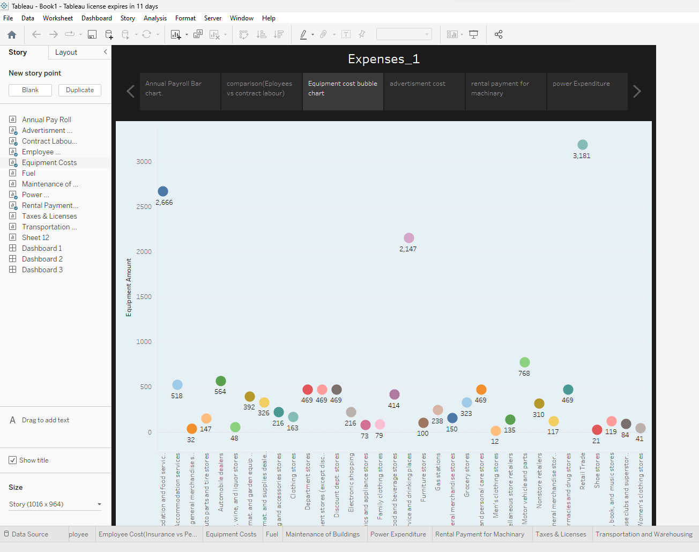

STORY 2

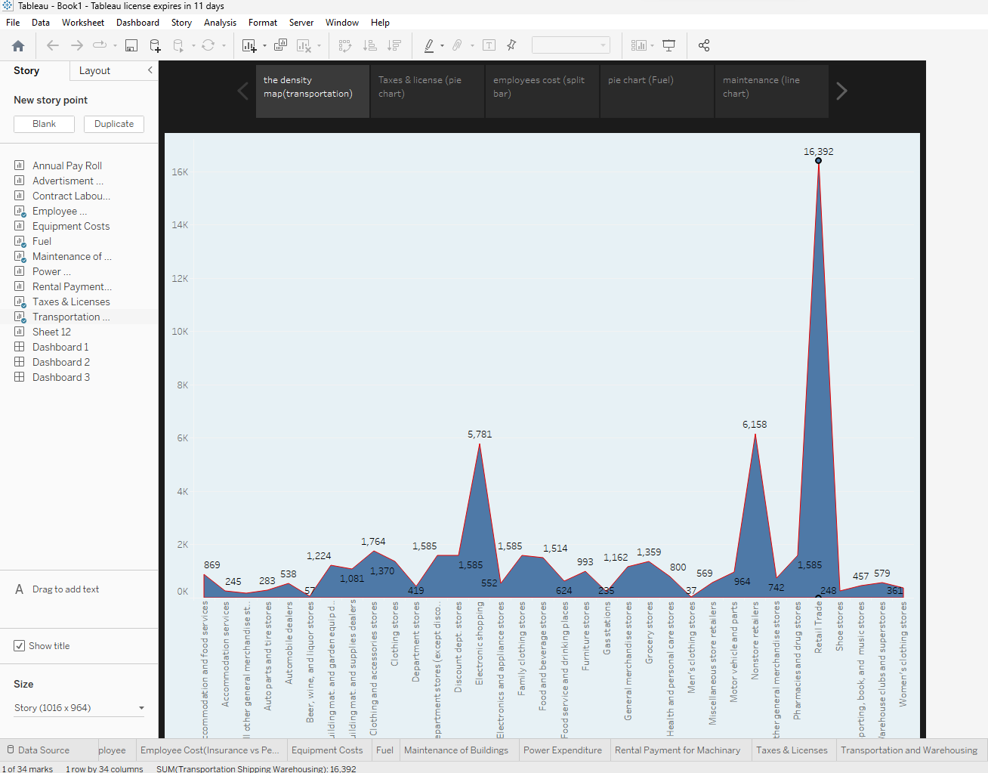

CONCLUSION

Estimation of business expenses are a crucial aspect of financial planning for any organization. They help in budgeting Forecasting, and making informed decisions.

Be as accurate as possible: accurate estimation are essential to prevent financial surprises and ensure the business operates within it’s means.